Classification of Heart failure using Machine learning: A Comparative study
INTRODUCTION:
Cardiovascular diseases (CVDs) are among the leading causes of death worldwide, with heart failure being a major health concern. Early prediction and diagnosis are important to reduce complications and improve patient outcomes. Machine Learning (ML) techniques can analyse clinical data and help in accurate heart disease prediction.
This study uses the “Heart Failure Prediction” dataset from Kaggle to predict heart disease using supervised ML algorithms including Logistic Regression (LR), Decision Tree (DT), Random Forest (RF), K-Nearest Neighbours (KNN), and Multi-Layer Perceptron (MLP). The models are compared using metrics such as Accuracy, Precision, Recall, and F1-Score to identify the best-performing model.
BASIC TERMINOLOGIES:
- Confusion Matrix: A table that shows correct and incorrect predictions made by the model.
- Accuracy: The percentage of total predictions that were correct.
- Precision: Out of all patients predicted as diseased, how many were actually diseased.
- Recall: Out of all actual diseased patients, how many were correctly identified by the model.
- F1 Score: A balanced measure that combines both precision and recall.
- AUC: Measures how well the model can distinguish between diseased and healthy patients.
- Specificity: Measures how correctly the model identifies healthy patients.
- Brier Score: Measures how accurate the model’s probability predictions are; lower values indicate better performance.
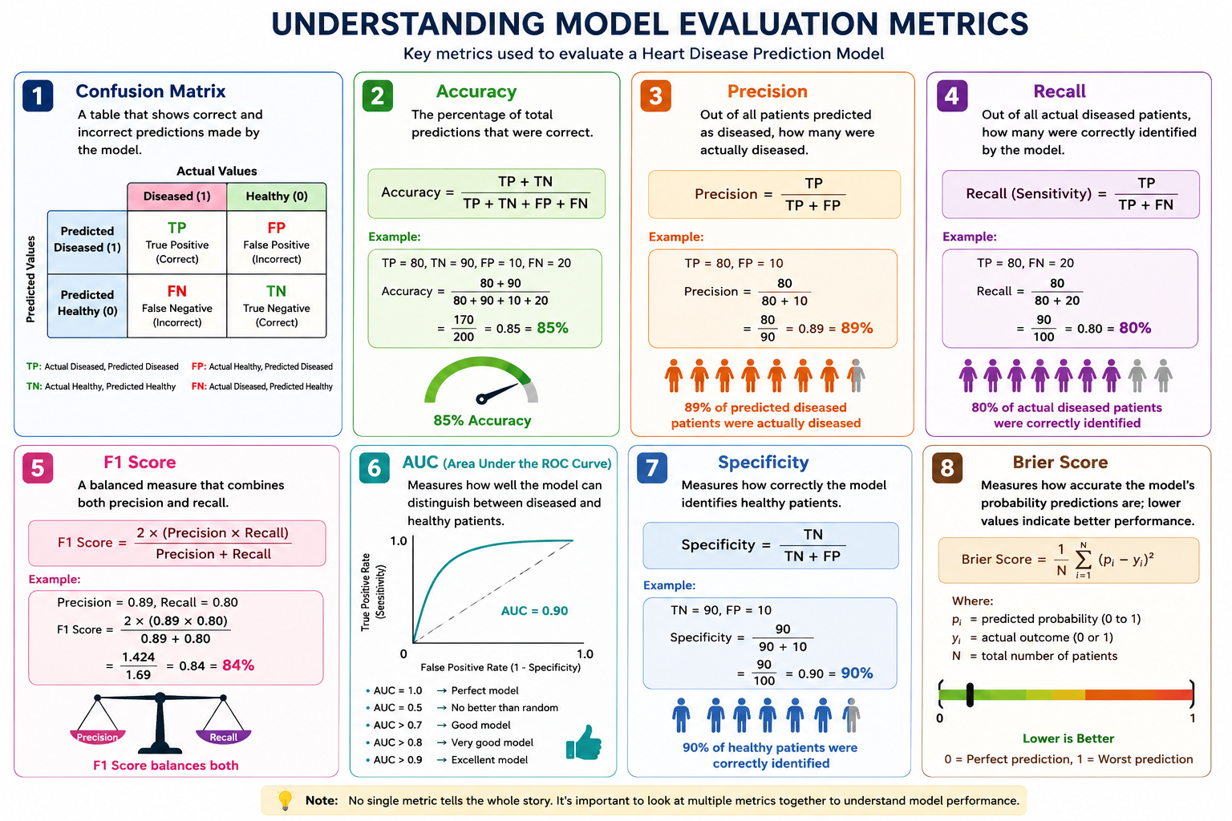
{Produced through ChatGPT}

MODELS USED: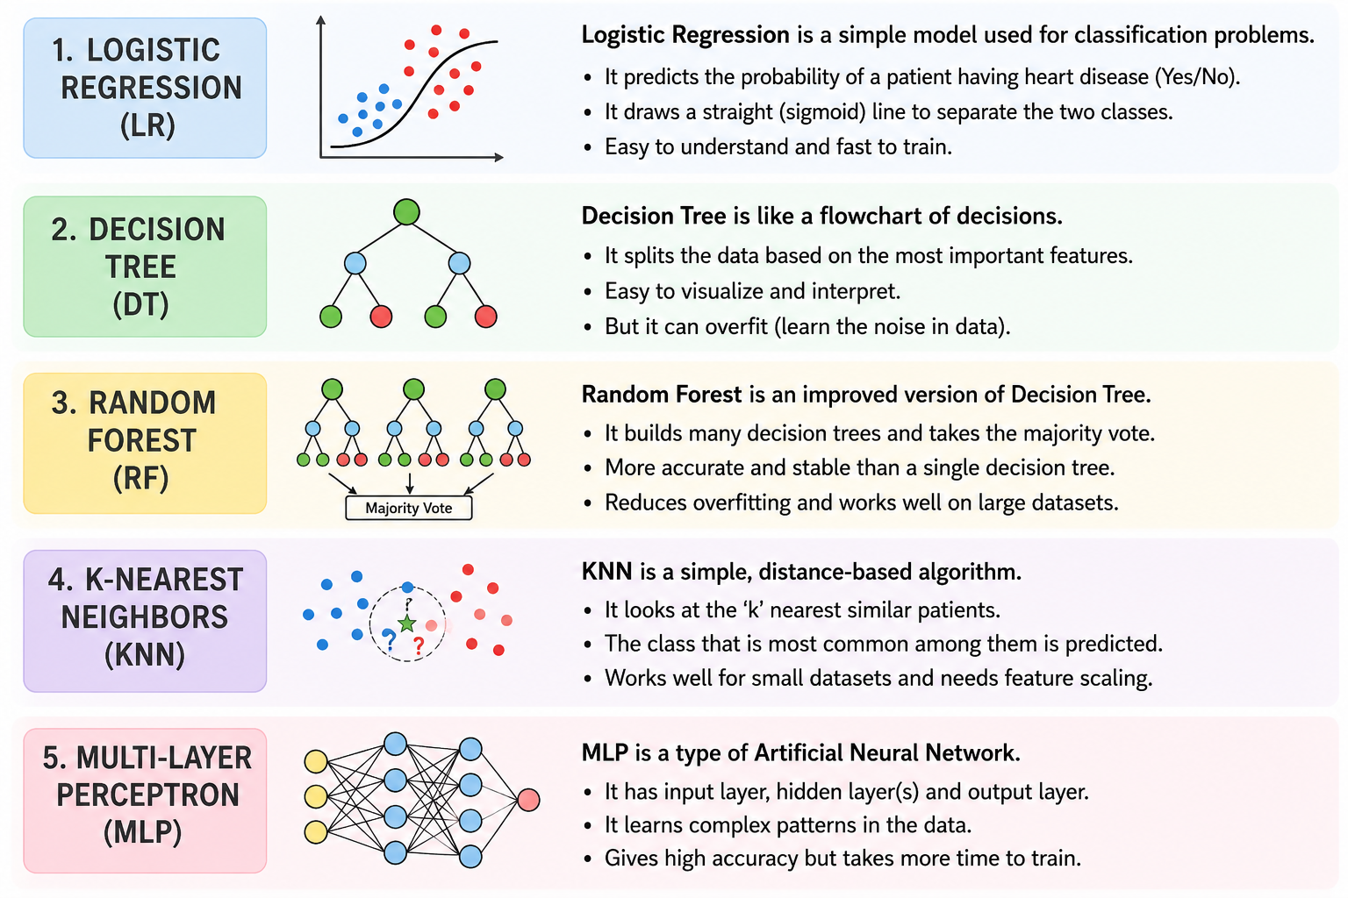
{Produced through ChatGPT}

DATASET USED:
Dataset Description
- Dataset Source: Kaggle
- Total Records: 918 patient records
- Total Features: 12 columns
- Target Variable: Heart Disease
  - 0 → No Heart Disease
  - 1 → Presence of Heart Disease
The dataset includes important clinical features such as:
Feature Name | Description
Age | Age of the patient
Sex | Gender of the patient
Chest Pain Type | Type of chest pain experienced
Resting BP | Resting blood pressure
Cholesterol | Cholesterol level
Fasting BS | Fasting blood sugar
Resting ECG | Resting electrocardiogram results
Max HR | Maximum heart rate achieved
Exercise Angina | Exercise-induced angina
Old peak | ST depression value
ST Slope | Slope of the ST segment
Heart Disease | Target column indicating heart disease

The dataset contains both numerical and categorical data with no missing/null values.
Label Encoding and Standard Scaler were applied during preprocessing to improve Machine Learning model performance.
LOGISTIC REGRESSION:
- Table 1. Logistic Regression (LR) Model Results Reported in the Research Paper
 | PRECISION | RECALL | F1 SCORE | SUPPORT
0 | 0.86 | 0.84 | 0.85 | 102
1 | 0.84 | 0.86 | 0.85 | 98
ACCURACY |  |  | 0.85 | 200
MACRO AVG. | 0.85 | 0.85 | 0.85 | 200
WEIGHTED AVG. | 0.85 | 0.85 | 0.85 | 200

ADDITIONAL METRICS: Specificity= 0.84; AUC= 0.94; Brier Score= 0.10; MCC= 0.70

- Table 2. Practical Results Obtained from the Implemented Logistic Regression (LR) Model
 | PRECISION | RECALL | F1 SCORE | SUPPORT
0 | 0.77 | 0.88 | 0.82 | 77
1 | 0.91 | 0.81 | 0.86 | 102
ACCURACY |  |  | 0.84 | 184
MACRO AVG. | 0.84 | 0.85 | 0.84 | 184
WEIGHTED AVG. | 0.85 | 0.84 | 0.84 | 184

ADDITIONAL METRICS: Specificity= 0.88; AUC= 0.90; Brier Score= 0.13; MCC= 0.69

ANALYSIS BETWEEN THE REPORTED AND THE PRACTICAL DATA:
- Slight differences exist between the research paper results and the implemented model results.
- These variations are normal in Machine Learning experiments.
- Differences may occur due to:
  - Random train-test split
  - Data preprocessing methods
  - Feature encoding techniques
  - Hyperparameter settings
  - System environment differences
- The research paper reported an accuracy of approximately 85%.
- The implemented Logistic Regression model achieved an accuracy of 84%.
- The obtained results are very close to the reported results.
- This confirms that the implementation was successful and the methodology was reproduced correctly.

DECISION TREE:
- Table 1. Decision Tree (DT) Model Results Reported in the Research Paper
 | PRECISION | RECALL | F1 SCORE | SUPPORT
0 | 0.86 | 0.94 | 0.90 | 102
1 | 0.93 | 0.85 | 0.89 | 98
ACCURACY |  |  | 0.90 | 200
MACRO AVG. | 0.90 | 0.89 | 0.89 | 200
WEIGHTED AVG. | 0.90 | 0.90 | 0.89 | 200

ADDITIONAL METRICS: Specificity= 0.94; AUC= 0.89; Brier Score= 0.10; MCC= 0.79

- Table 2. Practical Results Obtained from the Implemented Decision Tree (DT) Model
 | PRECISION | RECALL | F1 SCORE | SUPPORT
0 | 0.84 | 0.88 | 0.86 | 77
1 | 0.91 | 0.88 | 0.90 | 107
ACCURACY |  |  | 0.88 | 184
MACRO AVG. | 0.88 | 0.88 | 0.88 | 184
WEIGHTED AVG. | 0.88 | 0.88 | 0.88 | 184

ADDITIONAL METRICS: Specificity= 0.88; AUC= 0.95; Brier Score= 0.09; MCC= 0.76

ANALYSIS BETWEEN THE REPORTED AND THE PRACTICAL DATA:
- Initially, the Decision Tree model achieved an accuracy of 78% using default parameters.
- To improve performance, hyperparameter tuning was applied to the model.
- Hyperparameter tuning is the process of adjusting model settings such as:
  - Max depth
  - Min samples split
  - Min samples leaf
  - splitting criteria
to optimize model performance.
- After tuning the hyperparameters, the Decision Tree accuracy improved significantly from 78% to 88%.
- The tuning process reduced overfitting and improved the model’s ability to generalize on unseen data.
- The final tuned model produced results much closer to those reported in the research paper.

RANDOM FOREST:
- Table 1. Random Forest (RF) Model Results Reported in the Research Paper
 | PRECISION | RECALL | F1 SCORE | SUPPORT
0 | 0.90 | 0.93 | 0.92 | 102
1 | 0.93 | 0.90 | 0.91 | 98
ACCURACY |  |  | 0.92 | 200
MACRO AVG. | 0.92 | 0.91 | 0.91 | 200
WEIGHTED AVG. | 0.92 | 0.92 | 0.91 | 200

ADDITIONAL METRICS: Specificity= 0.93; AUC= 0.97; Brier Score= 0.06; MCC= 0.83
- Table 2. Practical Results Obtained from the Implemented Random Forest (RF) Model
 | PRECISION | RECALL | F1 SCORE | SUPPORT
0 | 0.86 | 0.90 | 0.88 | 77
1 | 0.92 | 0.90 | 0.91 | 107
ACCURACY |  |  | 0.90 | 184
MACRO AVG. | 0.89 | 0.90 | 0.89 | 184
WEIGHTED AVG. | 0.90 | 0.90 | 0.90 | 184

ADDITIONAL METRICS: Specificity= 0.90; AUC=0.94; Brier Score= 0.10; MCC= 0.79
ANALYSIS BETWEEN THE REPORTED AND THE PRACTICAL DATA:
- The Random Forest model produced results very close to those reported in the research paper.
- The research paper reported an accuracy of approximately 92%, while the implemented model achieved an accuracy of 90%.
- The implemented model also showed strong Precision (0.92) and F1 Score (0.91), indicating reliable classification performance.
- Minor differences between the reported and practical results are expected in Machine Learning experiments.
- These variations may occur due to:
  - Random train-test splitting
  - Different preprocessing methods
  - Feature encoding techniques
  - Hyperparameter settings
  - System and library version differences
- Random Forest outperformed most other implemented models because it combines multiple Decision Trees and reduces overfitting through ensemble learning.
- The high accuracy and balanced performance metrics indicate that Random Forest is highly effective for heart failure prediction.
- The close similarity between the reported and implemented results confirms the successful reproduction of the research methodology.

K- NEAREST NEIGHBOUR:
- Table 1. K-NN Model Results Reported in the Research Paper
 | PRECISION | RECALL | F1 SCORE | SUPPORT
0 | 0.78 | 0.69 | 0.73 | 102
1 | 0.71 | 0.80 | 0.75 | 98
ACCURACY |  |  | 0.74 | 200
MACRO AVG. | 0.74 | 0.74 | 0.74 | 200
WEIGHTED AVG. | 0.74 | 0.74 | 0.74 | 200

ADDITIONAL METRICS: Specificity= 0.84; AUC= 0.94; Brier Score= 0.10; MCC= 0.70
- Table 2. Practical Results Obtained from the Implemented K-NN Model
 | PRECISION | RECALL | F1 SCORE | SUPPORT
0 | 0.78 | 0.88 | 0.83 | 77
1 | 0.91 | 0.82 | 0.86 | 107
ACCURACY |  |  | 0.85 | 184
MACRO AVG. | 0.84 | 0.85 | 0.85 | 184
WEIGHTED AVG. | 0.85 | 0.85 | 0.85 | 184

ADDITIONAL METRICS: Specificity= 0.88; AUC= 0.92; Brier Score= 0.11; MCC= 0.70
ANALYSIS BETWEEN THE REPORTED AND THE PRACTICAL DATA:
- The K-Nearest Neighbours (KNN) model achieved better performance in the practical implementation compared to the results reported in the research paper.
- The research paper reported an accuracy of approximately 74%, while the implemented KNN model achieved an accuracy of 85%.
- The implemented model also produced higher Precision (0.91) and F1 Score (0.86), showing improved classification performance.
- One major reason for this improvement was the application of feature scaling using Standard Scaler during preprocessing.
- KNN is a distance-based algorithm, and feature scaling helps normalize the data, improving neighbour selection and prediction accuracy.
- Minor variations between reported and implemented results are common due to:
- Random train-test splitting
- Preprocessing differences
- Feature scaling methods
- Hyperparameter settings
- System environment differences
- The obtained results demonstrate that proper preprocessing can significantly improve the performance of the KNN model for heart failure prediction.

MULTI LAYER PROCESSING:
- Table 1. Multilayer Processing Model Results Reported in the Research Paper
 | PRECISION | RECALL | F1 SCORE | SUPPORT
0 | 0.94 | 0.75 | 0.84 | 102
1 | 0.79 | 0.95 | 0.86 | 98
ACCURACY |  |  | 0.85 | 200
MACRO AVG. | 0.86 | 0.85 | 0.85 | 200
WEIGHTED AVG. | 0.87 | 0.85 | 0.85 | 200

ADDITIONAL METRICS: Specificity= 0.84; AUC= 0.94; Brier Score= 0.10; MCC= 0.70
- Table 2. Practical Results Obtained from the Implemented Multilayer Processing Model
 | PRECISION | RECALL | F1 SCORE | SUPPORT
0 | 0.84 | 0.95 | 0.89 | 77
1 | 0.96 | 0.87 | 0.91 | 107
ACCURACY |  |  | 0.90 | 184
MACRO AVG. | 0.90 | 0.91 | 0.90 | 184
WEIGHTED AVG. | 0.91 | 0.90 | 0.90 | 184

ADDITIONAL METRICS: Specificity= 0.95; AUC= 0.95; Brier Score= 0.09; MCC= 0.81
ANALYSIS BETWEEN THE REPORTED AND THE PRACTICAL DATA:
- The Multi-Layer Perceptron (MLP) model achieved higher performance in the practical implementation compared to the results reported in the research paper.
- The research paper reported an accuracy of approximately 85%, while the implemented MLP model achieved an accuracy of 90%.
- The implemented model also produced very high Precision (0.96) and F1 Score (0.91), indicating strong predictive capability.
- The improved performance was mainly due to:
  - Proper feature scaling using Standard Scaler
  - Optimized hidden layer configuration
  - Better preprocessing and training setup
- MLP is a neural network-based model capable of learning complex nonlinear patterns in the dataset, which helped improve classification accuracy.
- Minor differences between the reported and implemented results are expected because of:
  - Random train-test splitting
  - Different preprocessing methods
  - Hyperparameter settings
  - Training iterations and system environment differences
- The high accuracy and precision obtained from the implemented model demonstrate that MLP is highly effective for heart failure prediction and performs competitively with Random Forest in this study.
OUTCOME:
- Five machine learning algorithms were implemented and compared for heart failure prediction: LR, DT, RF, KNN, and MLP.
- Random Forest (RF) and Multi-Layer Perceptron (MLP) achieved the highest accuracy and F1-Score among all models.
- Logistic Regression (LR) produced stable and balanced results with good overall performance.
- Decision Tree (DT) performance improved significantly after hyperparameter tuning, increasing accuracy from 78% to 88%.
- KNN performance improved due to feature scaling using Standard Scaler, achieving better accuracy than the research paper results.
- Random Forest performed best overall because ensemble learning reduced overfitting and improved generalization.
- MLP achieved the highest precision (0.96), showing strong reliability in predicting positive heart disease cases.
- The comparison shows that preprocessing and hyperparameter tuning play an important role in improving model performance.
- The implemented results were very close to the results reported in the research paper, validating the correctness of the implementation.
- The study demonstrates that Machine Learning models can effectively assist in early heart failure prediction and clinical decision-making.

Table 1. Overall Summary of Results Reported in the Research Paper

ML Algorithms |  | Confusion  0 | Matrix  1 | Precision | Recall | F1 Score
LR | 0  1 | 86  14 | 16  84 | 0.84 | 0.86 | 0.85
DT | 0  1 | 96  16 | 6  82 | 0.93 | 0.84 | 0.88
RF | 0  1 | 94  10 | 8  88 | 0.92 | 0.90 | 0.91
KNN | 0  1 | 70  20 | 32  78 | 0.71 | 0.80 | 0.75
MLP | 0  1 | 72  6 | 30  92 | 0.75 | 0.94 | 0.84

Table 2. Practical Results Obtained from the Implemented Multilayer Processing Model

ML Algorithms |  | Confusion  0 | Matrix  1 | Precision | Recall | F1 Score
LR | 0  1 | 68  20 | 9  87 | 0.91 | 0.81 | 0.86
DT | 0  1 | 68  13 | 9  94 | 0.91 | 0.88 | 0.90
RF | 0  1 | 69  11 | 8  96 | 0.92 | 0.90 | 0.91
KNN | 0  1 | 68  19 | 9  88 | 0.91 | 0.82 | 0.86
MLP | 0  1 | 73  14 | 4  93 | 0.96 | 0.87 | 0.91

